
Brigham Young University

W05 REFLECTION

Leida J. Pereira Hidrogo
Department, BYU-Idaho
REL250A: Religion
Sister Luanne Simmons
Date: December 03, 2025
Reflection:
Share your testimony of the divine birth of Jesus Christ via text or on social media. Submit a picture of your post or text in the space below.
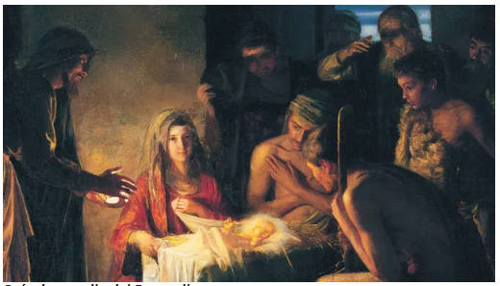
"December is a beautiful month; we share with our family in a climate of love, peace, and unity. Feelings that spring from the depths of our heart... I know that Jesus Christ lives to guide us through the Holy Spirit; I know that he was born of the Virgin Mary and Joseph, came into the world, and died on the cross to save us from our sins, in the name of our Lord Jesus Christ. Amen."
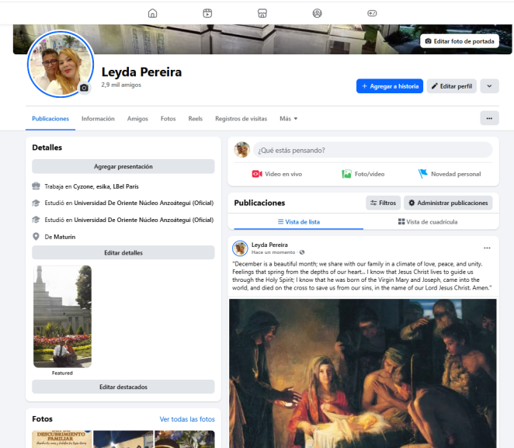
Link: https://www.facebook.com/leyda.pereira.5

